|  |  |
| --- | --- |
| محمد ربيع عبدالغني حسين | الاسم |
| 6 | جروب |
| 32 | سكشن |
| 703 | رقم الجلوس |
| Artificial Intellegance | الموضوع |

github Link: https://github.com/mohammed-ouf/html-progect-repository

Artificial Intellegance

Introduction to Artificial Intellegance

Artificial Intelligence refers to the intelligence of machines. This is in contrast to the natural intelligence of humans and animals.

With Artificial Intelligence, machines perform functionssuch as learning, planning, reasoning and problem-solving.

Most noteworthy,Artificial Intelligence is the simulation of human intelligence by machines.

It is probably the fastest-growing development in the World of technology and innovation.

What is the Artificial Intilligence?

Artificial intelligence (AI) is:

intelligence demonstrated by machines, unlike the natural intelligence displayed by humans and animals, which involves consciousness and emotionality.

The distinction between the former and the latter categories is often revealed by the acronym chosen. 'Strong' AI is usually labelled as artificial general intelligence (AGI) while attempts to emulate 'natural' intelligence have been called artificial biological intelligence (ABI). Leading AI textbooks define the field as the study of "intelligent agents": any device that perceives its environment and takes actions that maximize its chance of achieving its goals.[3] Colloquially, the term "artificial intelligence" is often used to describe machines that mimic "cognitive" functions that humans associate with the human mind,

such as "learning" and "problem solving".[4]

As machines become increasingly capable, tasks considered to require "intelligence" are often removed from the definition of AI a phenomenon known as the AI effect.[5],

A quip in Tesler's Theorem says "AI is whatever hasn't been done yet."[6] For instance, optical character recognition is frequently excluded from things considered to be AI,[7]

having become a routine technology.[8] Modern machine capabilities generally classified as AI include successfully understanding human speech,[9] competing

htmlصور

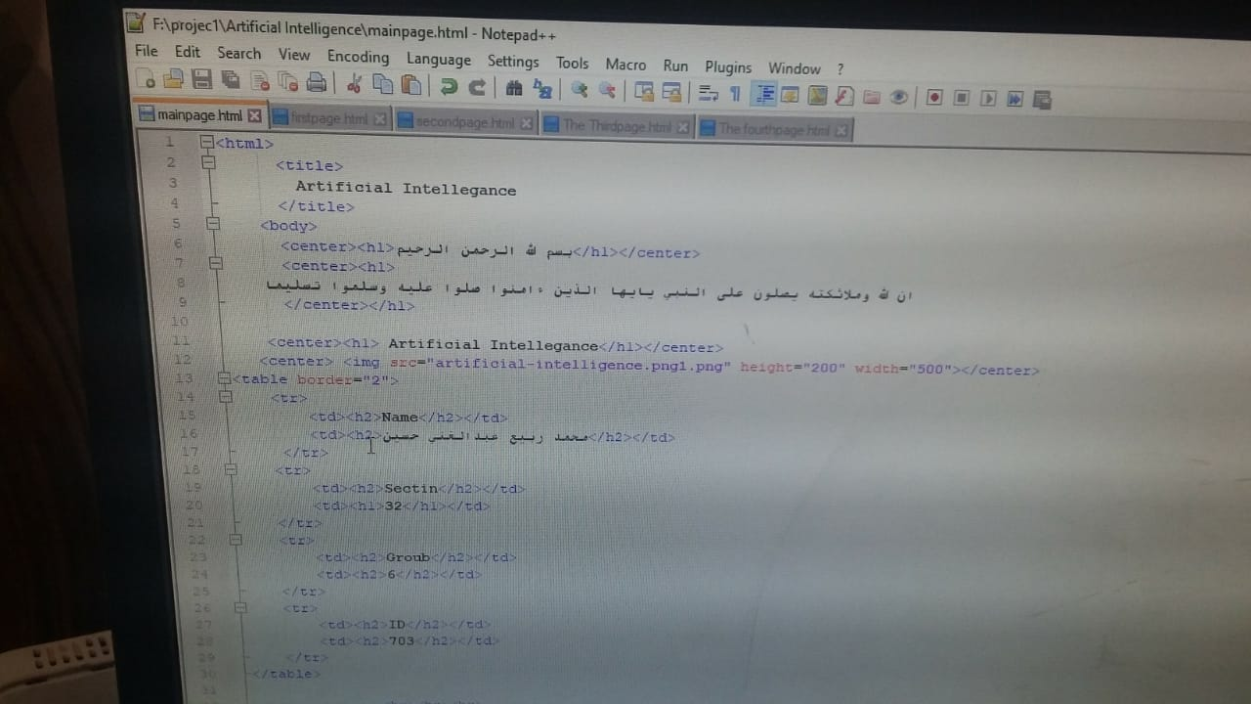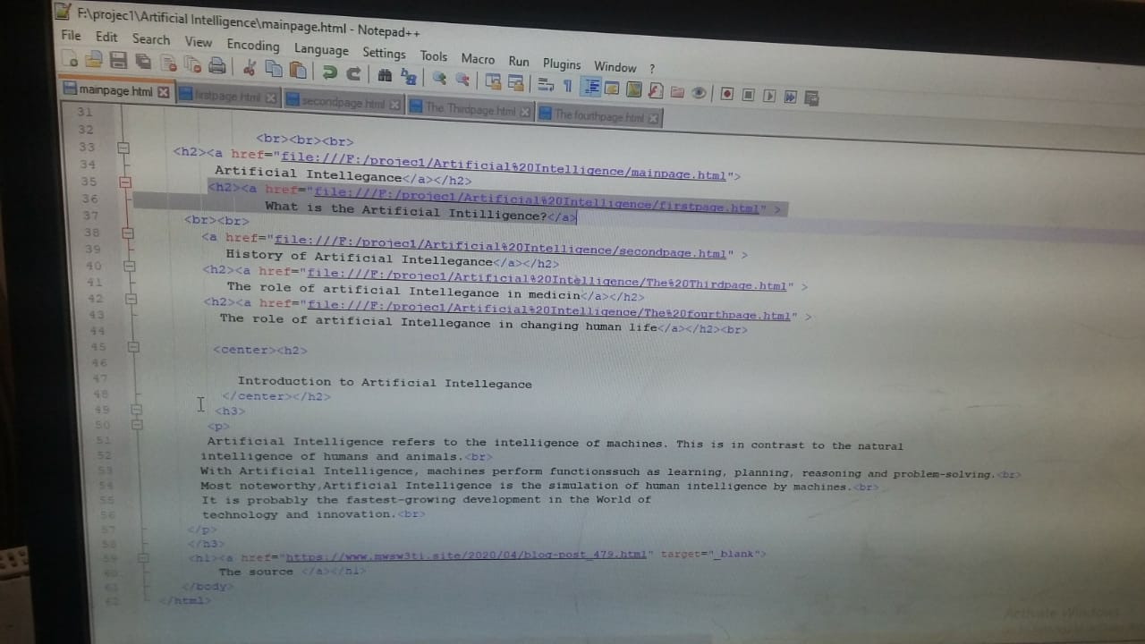

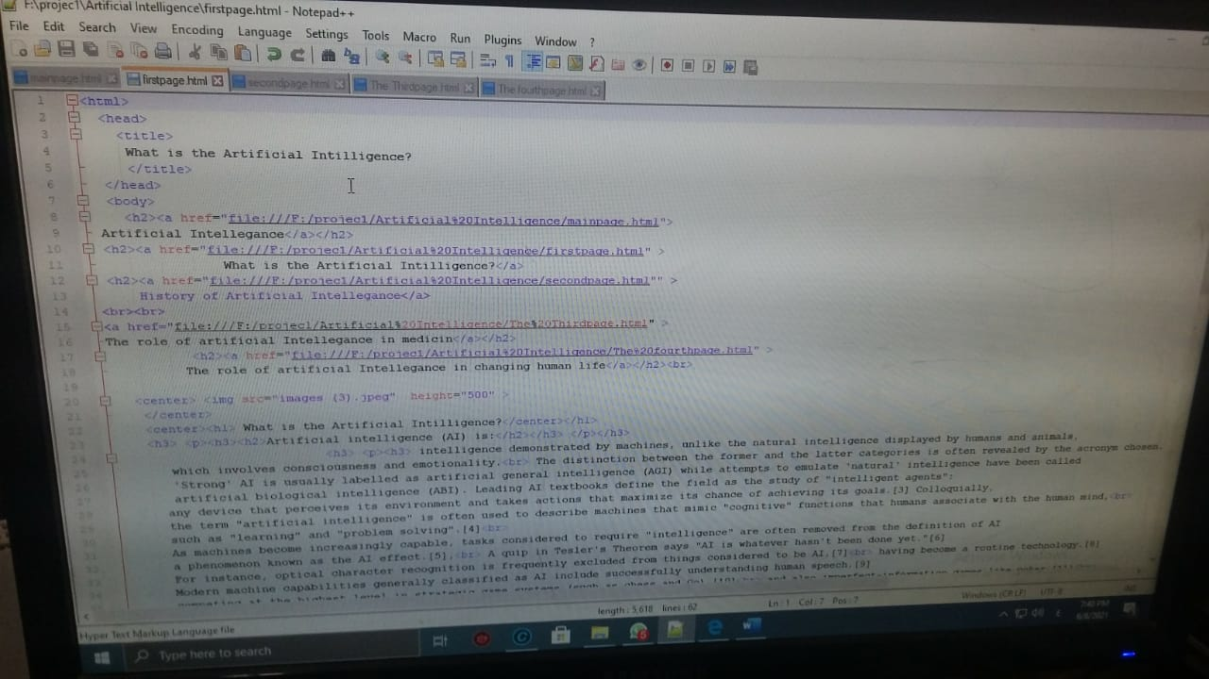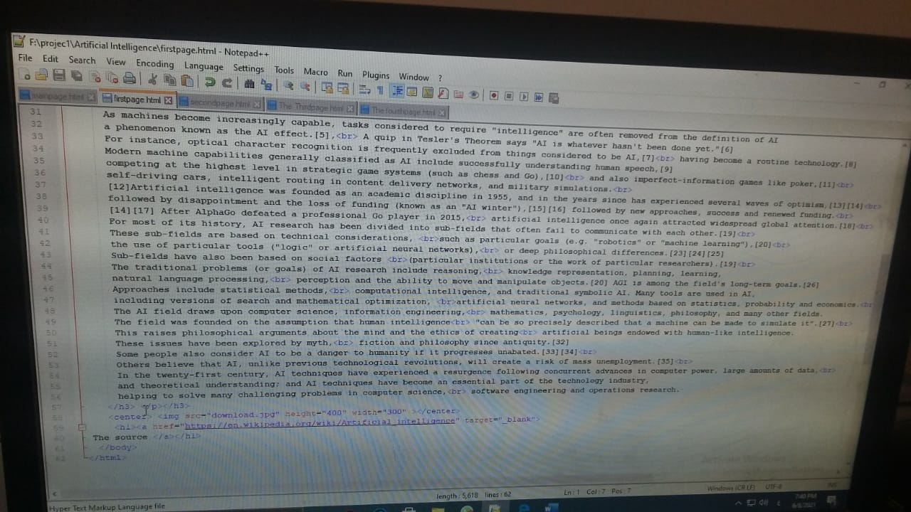

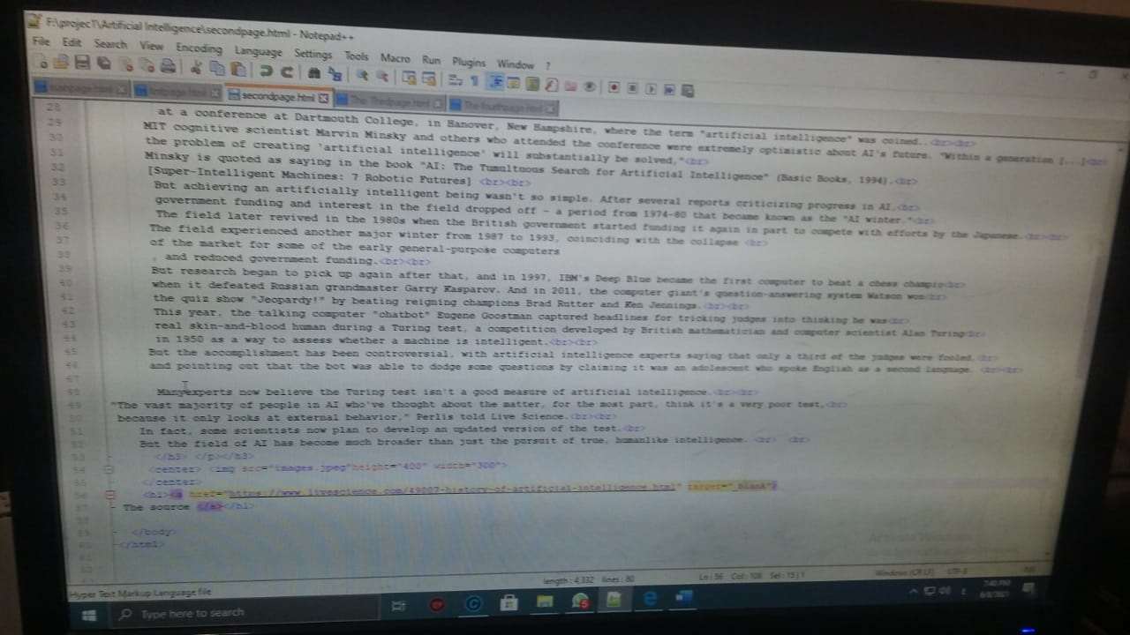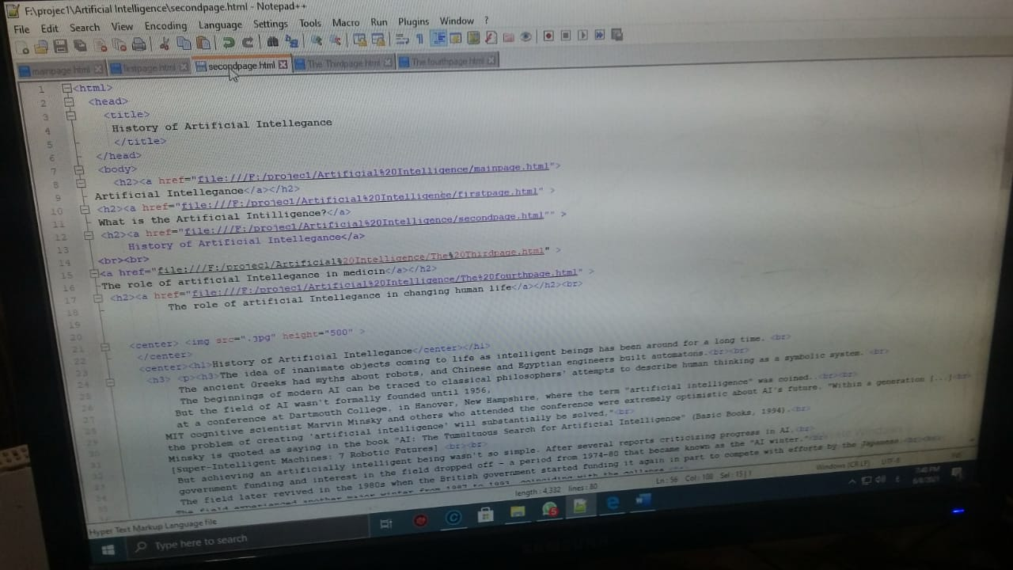

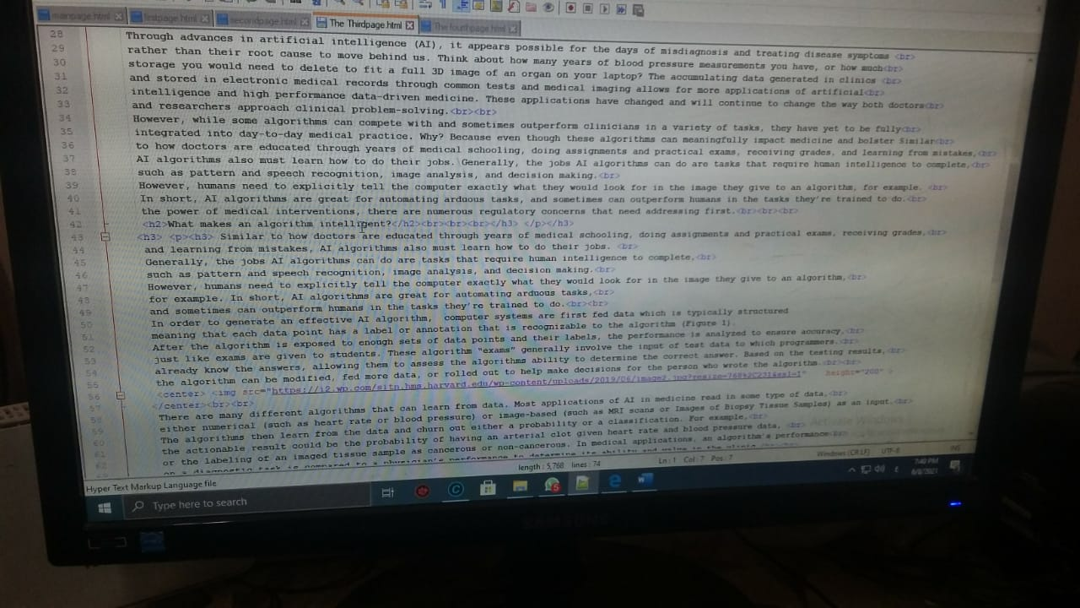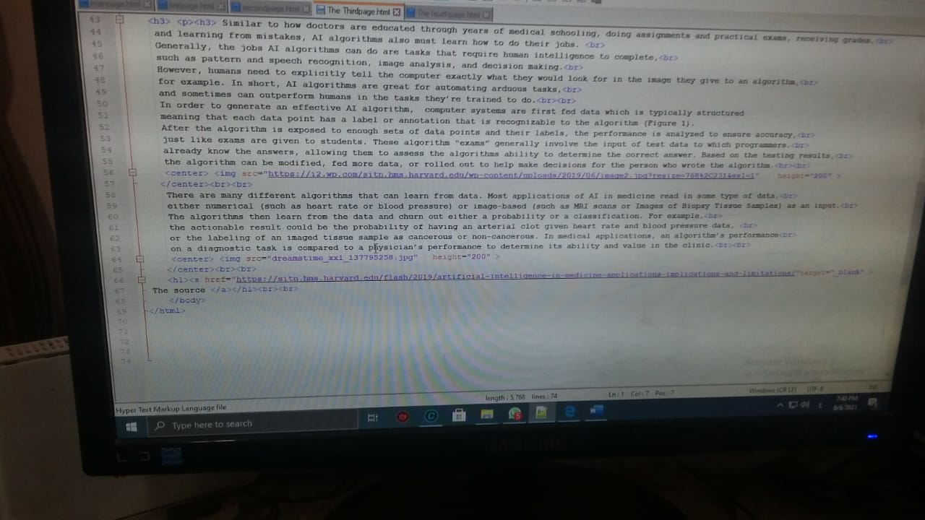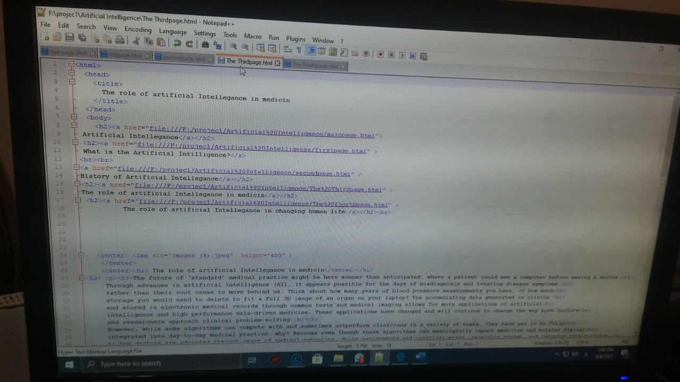

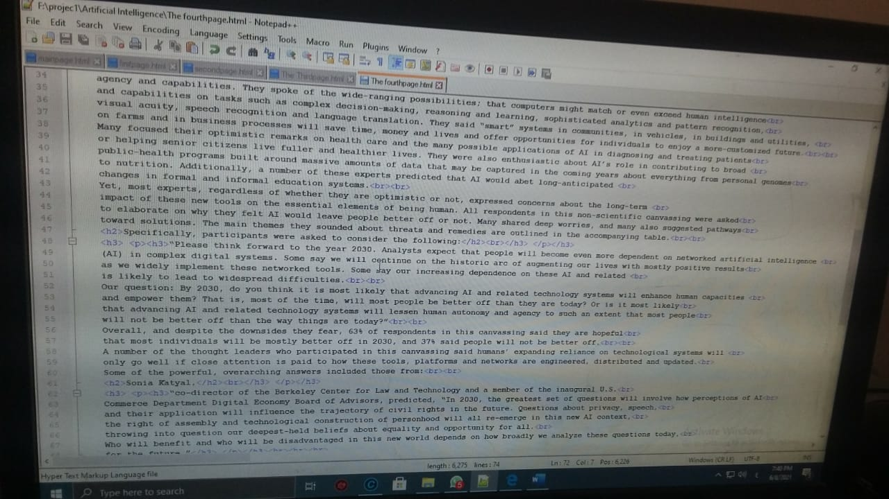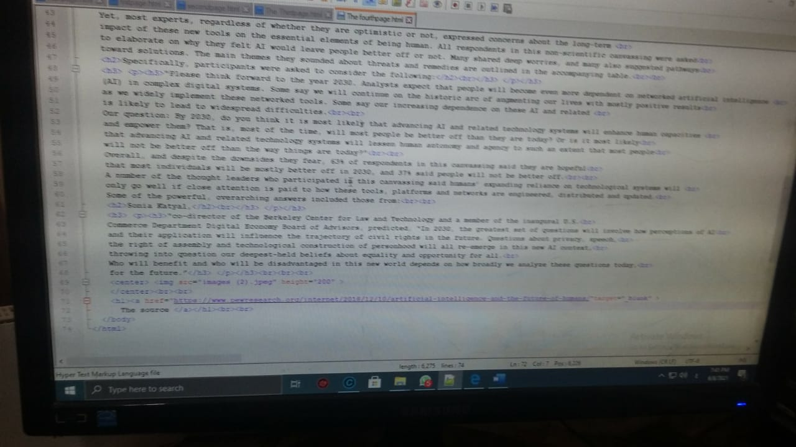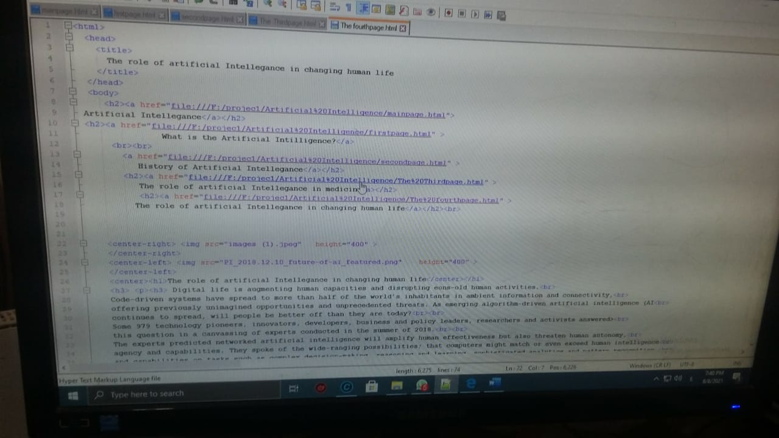

صور المشروع

